# Project Report

## Group: ________

Team member: André Pont x23164034

Team member: Grzegorz Pintal x23521803

Team member: Jordan Carthy x22113100

## Links:

GitHub: André - <https://github.com/andrepontde/Web-Design-Project-Team-AndGreJor.git>

GitHub: Jordan -

GitHub: Grzegorz - https://github.com/andrepontde/Web-Design-Project-Team-AndGreJor

Deployed: ________

Stream presentation video: ________

## Screen shots of Wireframes:

Products and Process page

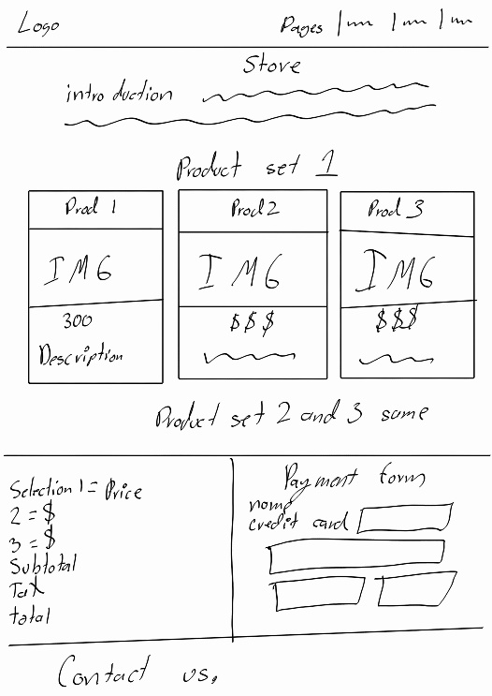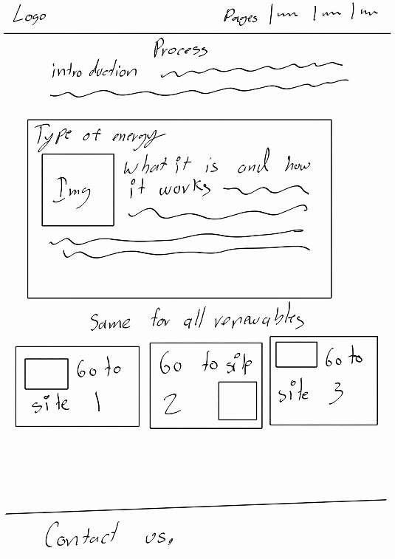

Renewable and Game

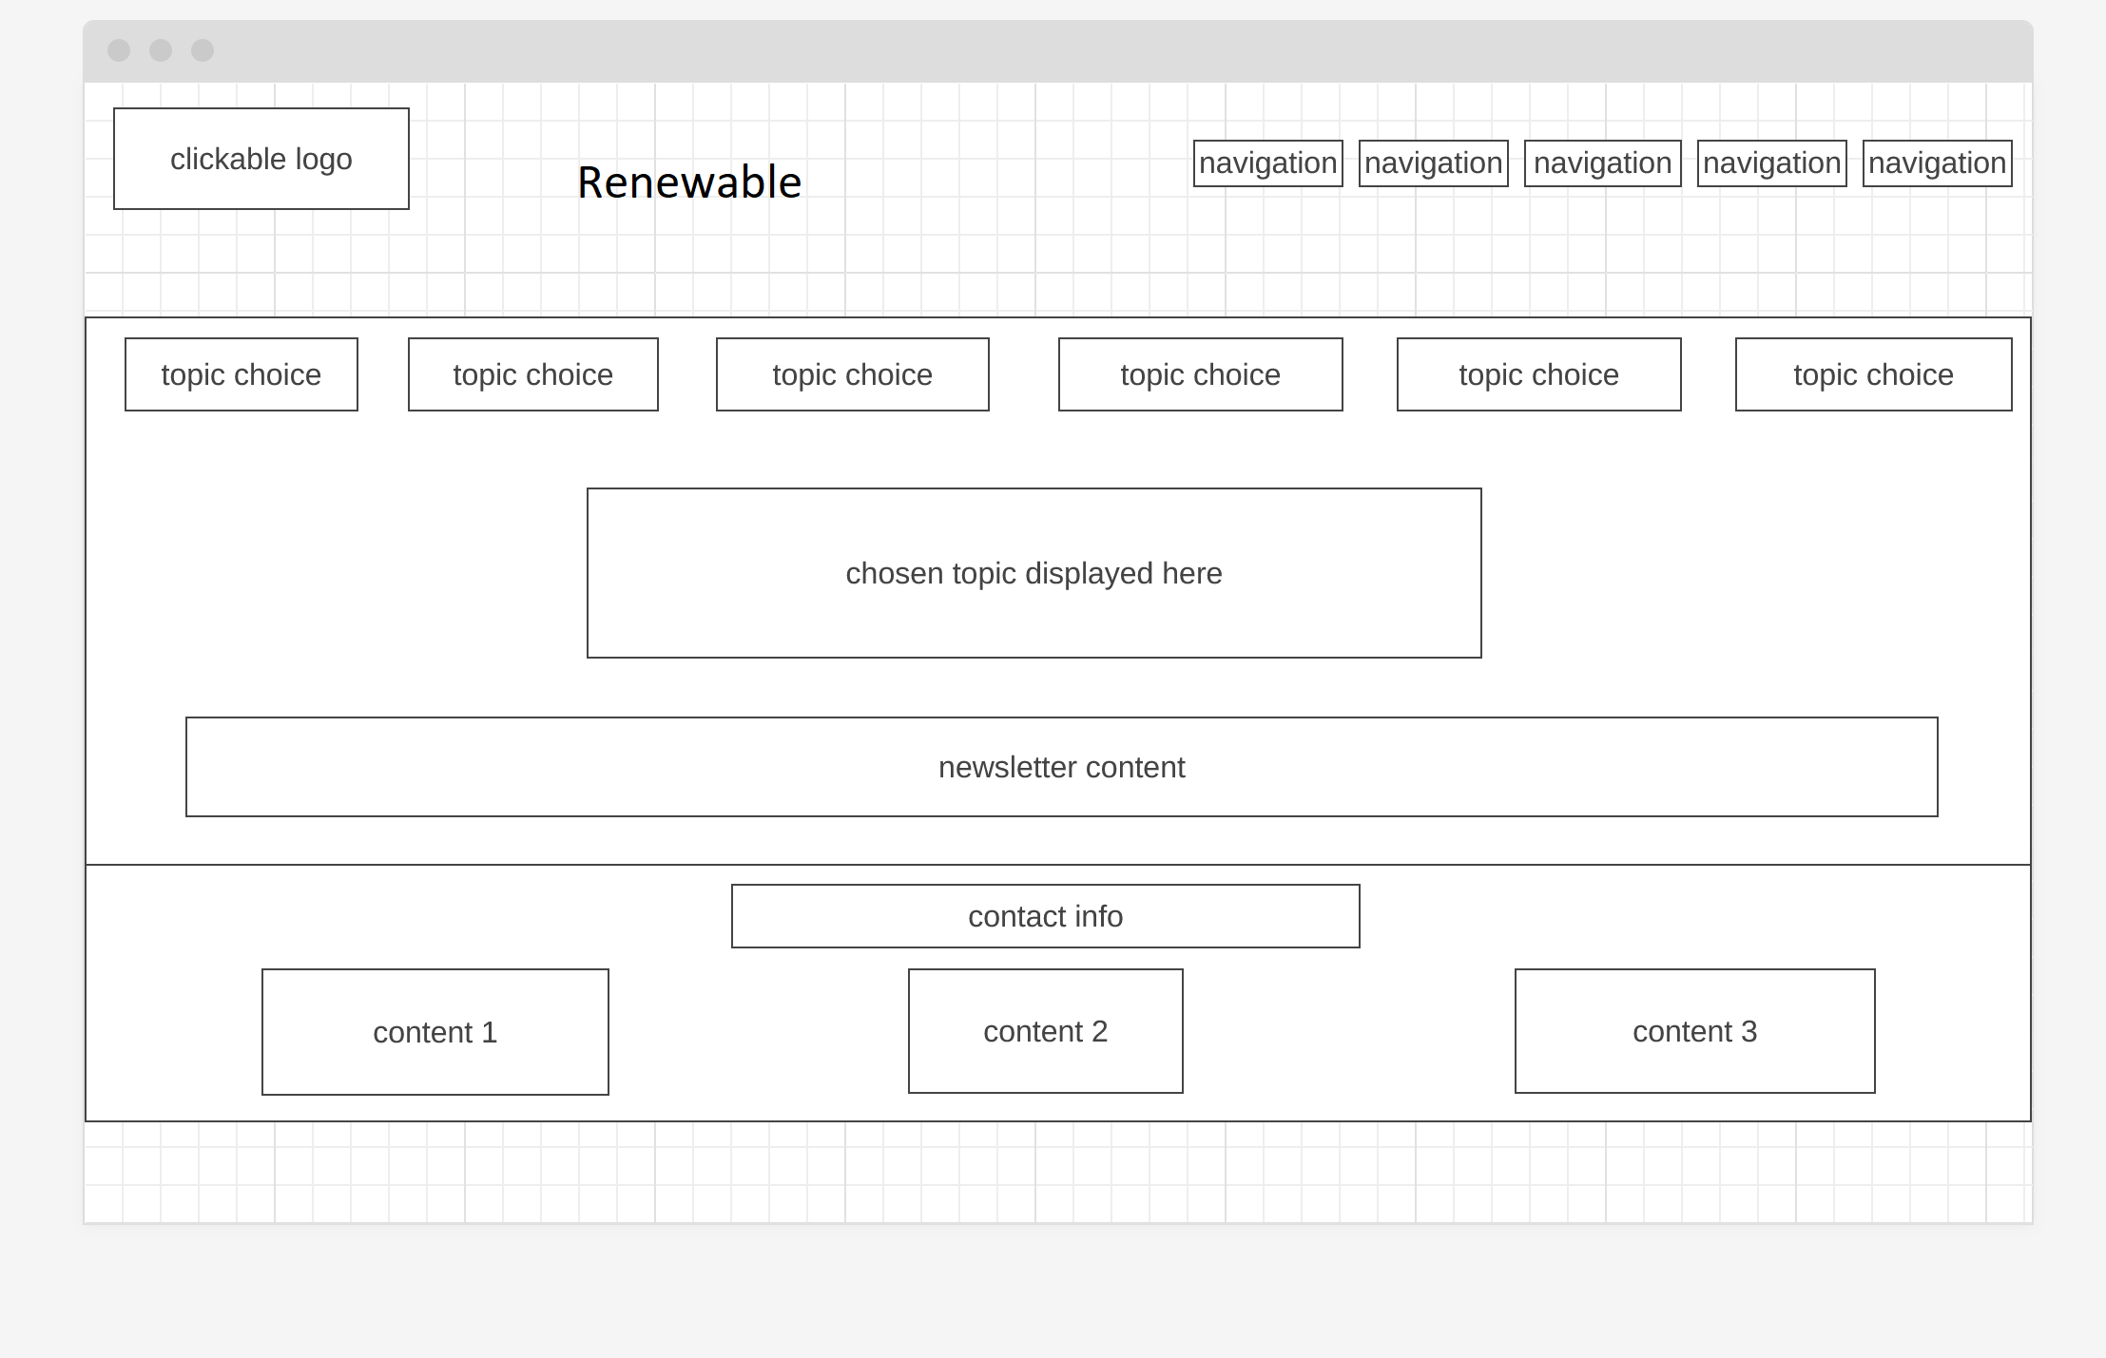

## Screen shots of Mood board:

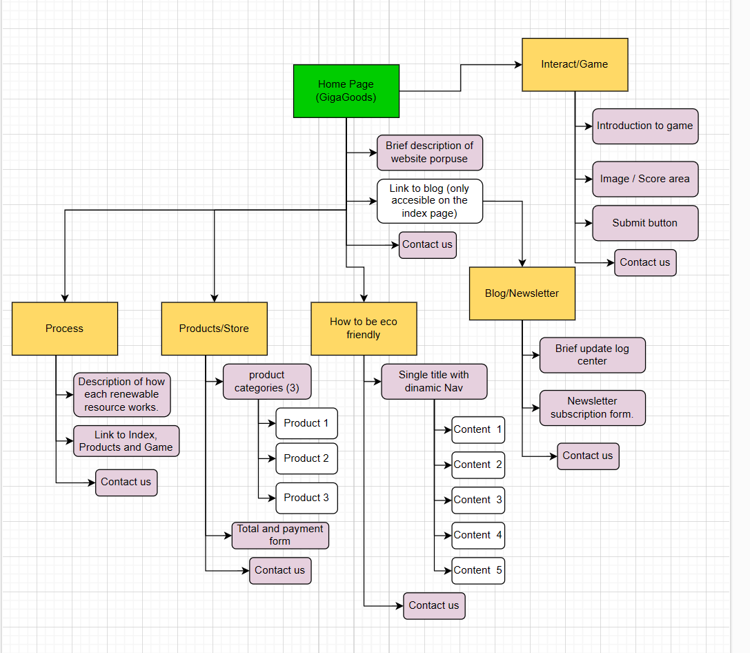

## How the website meets web standards:

## Coding challenge by team member 1 (André):

I was tasked with the product and process page, and since the number of services a page of this nature can provide is limited, I decided to approach the product page by making larger, more visible products, but within the small amount of categories and services a page like that would actually provide.

One of the challenges of the products page development was that the desired behavior of the DOM manipulation was not updating any of the values correctly, this due to the fact that other pages were calling their functions in the same JavaScript page, and since the id’s and values those functions were trying to collect were not necessarily in the same page, the site would break and it stopped before running any of the other main functions needed for the page to work. Furthermore, for it to function correctly, our solution was to make individual pages of JavaScript and link them to the corresponding page, thus solving the function problem.

The other problem with the products site was that It required too many function to perform a simple task, one for each product available and for each category, so instead of having 9 functions that did essentially the same, I decided to have 3 functions, one for each category, that would use a switch in each of them that would take the input value of the product to display different prices and update the subtotal, Tax and total values.

For the Process page, the challenge was mainly in the Front end, since the layout of the information had to be easy to read, so I decided to use the bootstrap Grid and Column layout to make a clean site that is also responsive.

## Coding challenge by team member 2:

## Coding challenge by team member 3:

## List of tasks assigned to team members:

Jordan: Index – Newsletter

André: Products – Process

Grzegorz: Game/Interact – Renewable

I DON’T KNOW IF THIS IS ENOUGH.